3GPP TSG-RAN WG1 #125 R1-2604712
Dalian, China, May. 18th ~ 22nd, 2026
Agenda item: 10.8.3
Source: Qualcomm Incorporated
Title: Sensing waveforms for 6GR air interface
Document for: Discussion/Decision

Introduction
In RAN1 #124bis, the following agreements were made regarding the sensing waveform:
Agreement:
CP-OFDM waveform as defined for 6GR is the starting point for 6G ISAC waveform study.
Study on enhancements on CP-OFDM or other waveforms is not precluded.

Agreement:
6GR communication frame structure is the starting point for 6G ISAC frame structure study, in at least the following aspects.
- Frame/sub-frame/slot/symbol structure
- CP length
- SCS
Enhancements on frame structure/above aspects are not precluded.

Agreement:
Companies are encouraged to provide views on necessity/pros/cons/metrics of LLS and/or SLS and pros/cons/metrics of theoretical waveform characteristics analysis, for evaluation of ISAC waveform and/or integration with communication, to RAN1#125 meeting.

Agreement:
CP-OFDM is used as the benchmark for evaluating the benefits of sensing waveforms.

This contribution focuses on:
- Discussion on new waveform families for 6G ISAC
- KPIs for sensing evaluation
- Evaluation methods for ISAC waveform study
- Enhancements to CP-OFDM waveform as defined for 6GR
- Frame structure enhancements over 6GR communication frame structure
- Discussion on specifying the waveform for TRP-sensing modes

On New Waveform Families for 6G ISAC
The following agreement was made regarding the ISAC waveform during RAN1 #124-bis:
Agreement:
CP-OFDM waveform as defined for 6GR is the starting point for 6G ISAC waveform study.
Study on enhancements on CP-OFDM or other waveforms is not precluded.

In this section, we compare the baseline OFDM-based waveforms of 6G communication, against alternative waveform families that have been proposed for ISAC, and argue that the former represents the most compelling overall choice for 6G ISAC.

Unlike conventional radar systems, where the waveform can be optimized exclusively for sensing performance, 6G ISAC must simultaneously satisfy communication, sensing, and deployment constraints. As a result, the waveform decision must balance sensing capability against ecosystem compatibility, hardware reuse, and standardization impact.

Several alternative waveform families have been proposed for ISAC, each motivated by specific sensing advantages:
- Radar-native waveforms, such as FMCW and pulsed waveforms, are frequently considered due to their excellent autocorrelation properties and widespread use in automotive radar. These waveforms can indeed offer strong sensing performance, particularly for monostatic operation. However, in a cellular context, they often introduce additional challenges, including the need for full-duplex or fast Tx/Rx switching, self-interference management, and non-trivial coexistence with communication traffic.

An important observation is that many of the benefits of radar-native waveforms can be approximated within an OFDM framework, for example, by synthesizing pulse-like or FMCW-like sequences using OFDM symbols and frequency-domain shaping. This approach preserves the core OFDM-based framework while enabling sensing optimized sequence design, thus avoiding the need to introduce fundamentally new waveforms.

- Other waveform families have also been discussed in the literature, (e.g. AFDM, PMCW). While each waveform family has specific merits, none currently demonstrates a sufficiently compelling system-level advantage to outweigh the cost, complexity, and ecosystem disruption associated with deviating from an OFDM-based unified 6G air interface. For example, OTFS (Orthogonal Time Frequency Space) is often highlighted for its robustness in doubly spread channels, as it operates natively in the delay–Doppler domain. However, the performance gap between OFDM-based waveforms and OTFS significantly narrows when interference-aware multi-symbol receiver design is considered [1].

Observation 2.1: Many of the benefits of radar-native waveforms (e.g. FMCW, pulsed waveforms) can be approximated within an OFDM framework by synthesizing pulse-like or FMCW-like sequences using OFDM symbols. This approach preserves the core OFDM-based framework while enabling sensing-optimized sequence design, thus avoiding the need to introduce new waveforms specifically for sensing.
From a sensing perspective, 6G communication waveforms support delay- and Doppler-domain estimation through well-established processing. However, it is well known that naïve, single-symbol OFDM sensing receivers can suffer performance degradation in ISAC scenarios characterized by large propagation delays (e.g., UAV sensing beyond the cyclic prefix length) and high Doppler shifts (e.g., fast-moving targets or high carrier frequencies). These effects manifest as inter-symbol interference (ISI) and inter-carrier interference (ICI), which limit target detection and parameter estimation performance if left unaddressed. Crucially, these limitations are not fundamental to the 6G communication waveforms itself, but rather to simplified receiver assumptions. When enhanced multi-symbol receive processing is employed—such as multi-hypothesis testing (MHT), multi-FFT per-symbol processing, or equivalent interference-aware algorithms—the impact of ISI and ICI can be largely mitigated. With such receivers, sensing based on 6G communication waveforms can be shown to achieve performance comparable to more specialized waveforms, even in challenging delay- and Doppler-spread scenarios. This observation fundamentally shifts the comparison from “waveform-limited” to “receiver-limited,” strongly favoring 6G communication waveforms due to their flexibility and maturity.

Observation 2.2: When evaluating new waveform families, it is important to consider the right receiver processing algorithms to ensure a fair comparison. In particular, when evaluating OFDM-based waveforms, limiting to single-symbol processing can lead to pessimistic results.

The following table summarizes the preceding discussion on different waveform families with their potential benefits and drawbacks.

Table 1 Different waveform families proposed for ISAC
Waveform family | Why it’s considered | Potential drawbacks
6G comm. waveforms (CP-OFDM and DFT-S-OFDM) | Reuse of comm. waveform/RS; “robust, flexible” 6G ISAC framework; day-1 deployment readiness | Baseline/single-symbol processing can be ICI/ISI limited if range>CP or Doppler large fraction of SCS; mitigated by enhanced Rx
Radar-native: FMCW | Good autocorrelation; PA-friendly; low Rx complexity; strong radar heritage | medium spec-impact if treated as new sensing RS
Radar-native: Pulse(s) | Motivated by half-duplex constraints and/or large-delay spread channels; targets certain link- budget/range constraints | tradeoffs around power boost, coexistence, and switching, FD assumptions
Other waveform families | Primarily motivated by high Doppler / large-delay spread channels | Typically have higher processing burden and lower “day-1” compatibility; high spec impact than baseline

Proposal 2.1: For the ISAC waveform study, focus on enhancing the CP-OFDM waveform defined for 6GR, leveraging insights from radar-native and sensing-optimized waveforms.

KPIs for Sensing and ISAC waveform Evaluations

KPIs for Sensing
The following proposal was made by the moderator during the previous meeting:

[FL3][H] Proposal 4.2.2-5
Study the necessity/benefits and the applicable scenarios/sensing modes of enhancement at least for the following aspects, from perspective of CP-OFDM waveform and RS sequence for 6G ISAC.
- Low PAPR
- Low ACLR/OOBE
- Ambiguity function characteristics
- Auto- or Cross-correlation
- Pulse-like generation (e.g, interference mitigation)
- Low sensing RS overhead
- Resilience to ISI (Inter-Symbol Interference) and/or ICI (Inter-Carrier Interference)
Other enhancements are not precluded.
Note: this does not mean that the agreement has specification impact.

When evaluating different waveforms for sensing, two sets of KPIs are useful to consider. The first set considers the salient features of the waveform such a PAPR characteristics, high PSLR and ISLR, tight time and frequency containment, etc. and the second set consider the waveform’s impact on the overall system performance. Both sets of KPIs are valuable to consider:

Proposal 3.1: For evaluating different waveforms for sensing, consider at least the following two sets of KPIs:
- Waveform characteristics
  - PAPR
  - Ambiguity function characteristics (e.g. auto-corr, ISLR, PSLR)
  - Cross correlation
  - Time/freq. waveform confinement
  - Emissions compliance
  - Resilience to ISI and/or ICI
- System-level performance
  - Missed Detection probability
  - False Alarm probability (Type 1 & 2)
  - Horizontal/vertical positioning Accuracy
  - Velocity Accuracy
  - latency
  - Integration/harmonization between sensing & communication
  - Transmitter/Receiver complexity
  - Low sensing overhead

Evaluation Methods for ISAC Waveform Study
The following agreement was reached related to the evaluation methods for ISAC waveform study:
Agreement:
Companies are encouraged to provide views on necessity/pros/cons/metrics of LLS and/or SLS and pros/cons/metrics of theoretical waveform characteristics analysis, for evaluation of ISAC waveform and/or integration with communication, to RAN1#125 meeting.

Based on the above agreement, we make the following list of pros/cons and observations:

Theoretical Waveform Characteristics
Pros
- Directly evaluates waveform-intrinsic properties, independent of channel or environment realization.
- Metrics such as AF main-lobe width (estimation accuracy), PSLR/ISLR (false alarm/miss-detection tendency), PAPR (Tx efficiency), and ambiguity properties are widely used in the radar community.
- Avoids the need for any new ISAC-specific channel modeling, enabling rapid and transparent comparison across many waveform candidates.
- Consistent with how communication waveforms are traditionally compared and selected in RAN1.

Cons
- Does not directly map to absolute system-level KPIs (e.g., detection probability under specific deployments).
- May not fully capture sensing–communication trade-offs unless complemented by limited simulations or additional statistical assumptions.

Observation 3.1: Waveform-characteristic analysis is the most suitable primary evaluation method for the ISAC waveform study, providing a clean, comparable, and low-risk foundation for waveform assessment.

Link-Level Simulations (LLS)
Pros
- Enables controlled evaluation of waveform-dependent sensing performance (e.g., SNR robustness, Doppler tolerance) while limiting system-level confounding factors.
- Can complement waveform-characteristic analysis if ambiguity-function-based metrics are insufficient for specific trade-offs (e.g., sensing–communication interaction).

Cons
- There is no agreed ISAC LLS sensing channel model resulting from Rel-19; adopting LLS would therefore require new channel model development.
- New LLS channel model may require now calibration phase across the companies, which would again require significant effort.
- Developing an ISAC-specific LLS model would significantly increase study complexity and timeline.
- Results may still depend on modeling assumptions (targets, reflections, clutter), reducing portability of conclusions across waveform candidates.

Observation 3.2: LLS may appear to be useful as a secondary or follow-up tool, but it is not well suited in the absence of an agreed ISAC LLS model and lack of time in the study item.

System-Level Simulation (SLS)
Pros
- Existing ISAC-capable SLS frameworks can be reused without defining a new LLS sensing channel model.
- Allows joint consideration of sensing and communication performance under deployment-level assumptions (e.g., scheduling, interference, mobility).
- By agreeing on a concise set of target and sensing-Tx/sensing-Rx dropping constraints, and avoiding the specification of a new channel model, system-level dependencies can be isolated from the ISAC waveform study, allowing a cleaner waveform-level evaluation.

Cons
- SLS performance is influenced by channel, environment, topology, and scheduler assumptions, making it difficult to isolate waveform-intrinsic properties.
- Requires extensive assumption alignment across companies to ensure fair comparison, which is time-consuming and has been repeatedly flagged as a risk by multiple delegates.

Observation 3.3: SLS-based evaluation avoids the specification of a new channel model. Further, agreements on a concise set of constraints to drop targets and sensing-Tx/sensing-Rx nodes, can help isolate system-level dependencies from the ISAC waveform study, allowing for a cleaner waveform-level evaluation.

Proposal 3.2: For the ISAC waveform study in RAN1, use the theoretical waveform characteristics analysis as the primary evaluation method, and complement it with a SLS with agreed evaluations assumptions tailored for ISAC waveform evaluation study.

As examples of tailored evaluation constraints for ISAC waveform study, a simplified evaluation setup may be adopted in which each simulation run considers a single sensing mode with a single sensing transmitter (STx) and a single sensing receiver (SRx), under a single-cell, interference-free baseline without inter-cell interference. Each drop further assumes a single sensing target with line-of-sight (LOS) conditions for both the STx–target and target–SRx paths. To capture key waveform-dependent performance trends, two operating regimes may be defined: a near-range, high-SNR regime to highlight waveform ambiguity properties and sidelobe behavior, and a far-range, low-SNR regime to assess detection sensitivity and robustness. This constrained setup allows isolation of waveform-intrinsic effects while minimizing system-level artifacts.

Proposal 3.3: For the ISAC waveform study in RAN1, for the waveform-tailored SLS evaluation assumptions, consider at least the following:
- Single sensing transmitter (STx) and single sensing receiver (SRx)
- Single cell / interference-free
- One or two sensing targets
- LOS STx-target and target-SRx conditions
- Near (high SNR) and far away (low SNR) regimes

Enhancements based on 6G comm. waveforms

Pulse-Based Sensing & Full Duplex
There are specific operating regimes—such as TRP-centric monostatic sensing with full-duplex limitations, large delay spreads, or constrained link budgets—where 6G-communication-waveform-based sensing might face practical challenges or require increased receiver complexity to maintain performance. In these scenarios, short-duration pulse-based transmissions are being proposed, in principle, to offer attractive properties such as reduced self-interference exposure, improved time-domain localization, and clearer separation between transmit and receive phases, which may translate into measurable sensing gains. At the same time, it is well understood that such benefits are scenario-dependent and may diminish or disappear once advanced multi-symbol processing is applied, or in scenarios having FD systems with good self-interference cancellation properties.
In parallel, it is important that any potential pulse-based solution remains compatible with the 6G design principle of waveform reuse and minimal specification impact. Pulse-like sensing signals can be synthesized within an OFDM framework, without introducing a fundamentally new waveform or altering the baseline frame structure. It is also important to ensure compatibility on the hardware front as pulsed radars typically transmit at very high powers over short periods in time and require a very different approach to RF front-end design. Communication systems are designed to consistently transmit at a certain transmit power over sustained periods in time. This contrasts with the needs of a pulsed radar system and aspects such as boosting power cannot be taken for granted.
Pulsed-OFDM (with a zero header (H), a pulse (P), and a zero tail (T) ) may be worth investigating considering metrics such as low-PAPR, tight time-frequency containment and good correlation properties with reasonable complexity. Pulsed-OFDM design within CP-OFDM waveform should be flexible enough to enable multiple pulses within a symbol and configurability of pulse/tail/header duration for different maximum delay spreads in different FD/HD scenarios. A short-duration pulse and multiple such pulses within a symbol will be useful for half-duplex monostatic sensing, whereas a long-duration pulse can be used to deal with large delay spread scenarios. The next section elaborates on how one can realize FMCW-like pulses using OFDM as the baseline framework.
Proposal 4.1: Consider pulse-based waveforms for 6G ISAC waveform study. Study how pulse-based waveforms can be generated using 6G communication’s OFDM-based waveform generation framework.
FMCW waveforms can be viewed as one form of pulse-based waveforms. They are very widely used and have found great commercial success. In the following section, we discuss how FMCW-like waveforms can be synthesized using an OFDM-based framework for both pulsed and continuous modes of operation.

FMCW-like waveforms using optimized sequences within CP-OFDM
The following agreement was made regarding the ISAC waveform during RAN1 #124-bis:
Agreement:
CP-OFDM waveform as defined for 6GR is the starting point for 6G ISAC waveform study.
Study on enhancements on CP-OFDM or other waveforms is not precluded.

FMCW radars are very widely used across different applications and it useful for us to build support in 6G for an FMCW-like mode of operation for sensing using an OFDM transceiver. LFM chirps are widely used in FMCW radars and exhibit good auto-correlation properties as well as being constant modulus in time domain. Emulating LFM chirps in time domain via a carefully designed sequence for a RS using the OFDM framework is a worthwhile undertaking.
With regards to the enhancements on CP-OFDM, enhanced OFDM implementations of FMCW-like chirp are worth considering due to their low PAPR benefits, which could enable power boost and lead to robust target detection with high estimation accuracy. The use of FMCW-like chirp within a symbol or over multiple symbols can also enable good sensing performance in large delay and Doppler spread scenarios with reasonable receiver complexity.
In the following, we investigate how FMCW-like waveforms can be generated using Zadoff-Chu sequences as the starting point. We show a deep connection between LFM chirps and ZC sequences and use these connections to help construct new sequences for sensing that take us very close to FMCW-like operation.

Observations on ZC sequences
5G NR utilizes ZC sequences for SRS as well as for uplink DMRS in certain cases. ZC sequences satisfy the CAZAC property (constant amplitude zero autocorrelation) and are expected to exhibit low PAPR characteristics. From a sensing perspective, they appear to show LFM-like characteristics, but don’t quite mirror such chirps. We first examine where and why waveforms constructed using ZC sequences deviate from LFM chirps.
ZC sequences are expected to exhibit near-zero PAPR characteristics owing to their CAZAC property and because the Fourier transform of a ZC sequence is another ZC sequence. This however does not hold good when the time-domain waveform corresponding to these sequences is upsampled. This is visualized in Figure 4-1, where it is observed that the amplitude of a ZC sequence is not constant when visualized after upsampling as compared to an LFM chirp with large enough sampling frequency. Upsampled points exhibit variations in amplitude while the original sample points are all at a constant amplitude (owing to them corresponding to a ZC sequence). This is also evidenced in the deviations from linearity of the instantaneous frequency as seen in the figure below. The perturbation in the instantaneous frequency may also impact the auto-correlation characteristics.

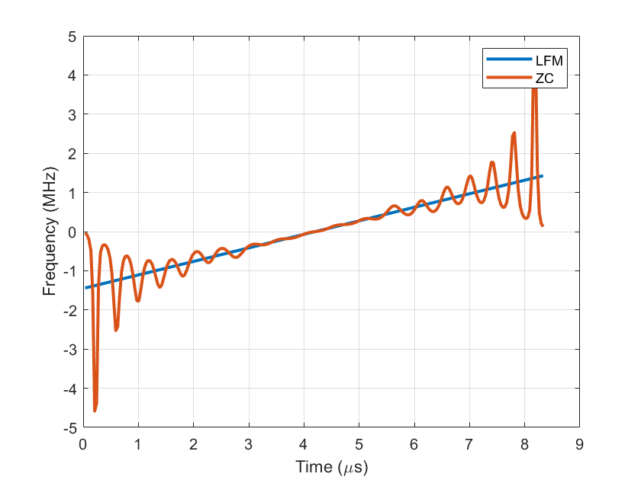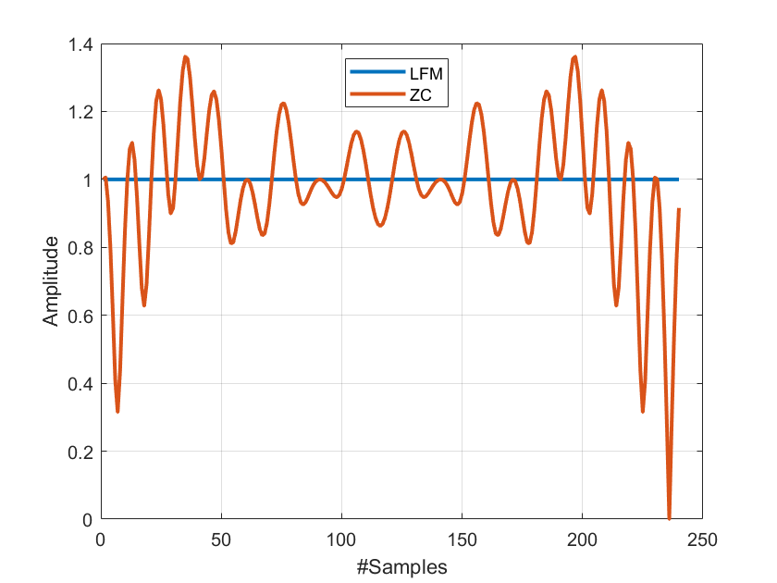
Time domain amplitude
Freq. vs Time
Figure 4-1 Upsampled ZC sequence of root one as compared to discretized LFM chirp with large enough sampling rate. Note the variations in time-domain amplitude and f versus t curve at upsampled points.
Observation 4.1: Upsampled waveforms constructed using ZC sequences do not exhibit a constant amplitude.
In the next section, we elaborate on the relationship between LFM chirps used by FMCW radars and the ZC sequences used in 5G NR with the goal of designing new sequences that are able to more faithfully recreate an LFM waveform when using an OFDM transmitter.

Relationship between FMCW chirps and ZC sequences
FMCW waveforms, such as linear frequency modulated (LFM) chirps, have constant modulus and therefore ideal PAPR properties. ZC sequences can be seen as an attempt at recreating an LFM chirp using OFDM implementations. There are, however, some compromises being made to preserve the CAZAC property at the cost of poor PAPR. In this section, we will see what those compromises are and how we can better design enhanced ZC sequences that can then be used generate waveforms that more closely resemble LFM chirps.
First, we present a detailed analysis for ZC sequences with time-domain root $q_{t}=1$. This analysis can also be extended to roots greater than 1, providing a unified approach to designing a set of enhanced ZC sequences.
Consider a time-domain continuous LFM chirp with sweeping bandwidth $B_{LFM}$, duration $T_{LFM}$, and chirp rate $γ= \frac{±B_{LFM}}{T_{LFM}}$. Its instantaneous frequency is a linear function of time and sweeps over $B_{LFM}$, as shown in Figure 4-2. The LFM chirp can be expressed as
$$x_{LFM}\left(t\right)=\exp\left(j π γt^{2}\right), 0≤t≤T_{LFM}.$$

$$γ$$
$$B_{LFM}$$
$$T_{LFM}=T$$
$$t$$
$$f$$
Sweeping bandwidth
Chirp duration
Figure 4-2 Parameters that define an LFM Chirp.
Let $x_{ZC}\left(m\right)$ denote a ZC sequence in the time domain with root $q_{t}=1$ and length $M_{ZC}$. We also denote OFDM symbol duration without the cyclic prefix as $T$ and the subcarrier spacing as $Δ_{SCS}$. It is interesting to note that both the phase of $x_{ZC}\left(m\right)$and the phase of $x_{LFM}\left(t\right)$ depend on time in a quadratic manner. Indeed, with the proper choice of LFM parameters, where $x_{LFM}(t)$ is configured to sweep over $M_{ZC}$ subcarriers (i.e., $B_{LFM}=M_{ZC}Δ_{scs})$ and $T_{LFM}=T$, ZC sequence becomes equal to $x_{LFM}\left(t\right)$ sampled at $M_{ZC}$ equidistant points $t_{m}$ with sampling time $T_{s}=1/B_{LFM}$ up to a constant phase factor $e^{jϕ}$, and is given by
$$x_{ZC}(m)={e^{jϕ}x}_{LFM}\left(t_{m}\right), t_{m}=t_{0}+mT_{s},$$
In particular, ZC with time-domain root $q_{t}=1$ and an odd length $M_{ZC}$ can be derived from the discretized LFM chirp with start time $t_{0}=0.5T_{s}$, which is given by
$$x_{ZC}\left(m\right)=exp\left(jπ\frac{m^{2}+m}{M_{ZC}}\right).$$
Observation 4.2: A Zadoff-Chu sequence with time-domain root $q_{t} = 1$ and length $M_{ZC}$ can be derived from a LFM chirp that sweeps over $M_{ZC}Δ_{scs}$ bandwidth by taking $M_{ZC}$ equidistant samples over an OFDM symbol duration.

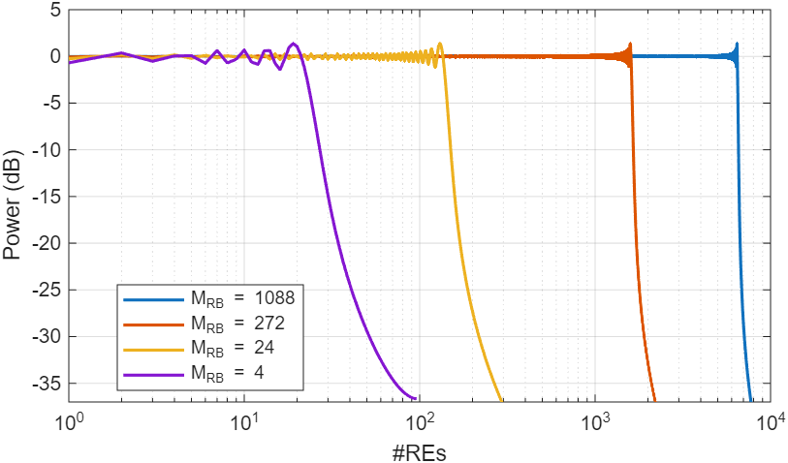
$$B_{20dB}/2$$
$$B_{LFM}/2$$
Figure 4-3 LFM spectrum with root of one and different allocated #RBs.
The spectrum of an LFM chirp, $x_{LFM}(t)$, however, is not bandlimited and a sizeable portion of the spectrum (such as the 20 dB bandwidth, $B_{20dB}$) is beyond the sweeping bandwidth, as shown in Figure 4-2. Hence, sampling an LFM chirp at a rate equal to the sweeping bandwidth $B_{LFM}$is insufficient to accurately reconstitute $x_{LFM}(t)$ as a substantial amount of aliasing is incurred. Due to this under-sampling, continuous-domain waveforms generated using ZC sequences do not exhibit the constant amplitude property associated with LFM chirps, as shown in Figure 4-1. This leads to an increase in the PAPR of the final waveform generated using ZC sequences and ultimately limits the maximum transmit power available for the waveform.
Observation 4.3: Spectrum of an LFM chirp extends beyond sweeping bandwidth. Therefore, ZC sequence derived from LFM chirp sampled at sweeping bandwidth suffers from aliasing.

“FMCW-like” sequences: Low-PAPR, FMCW hardware reuse
The aliasing issue can be mitigated by first increasing the sampling rate above the sweeping bandwidth to obtain ${\tilde{X}}_{EZC}\left(f\right)$, as shown in Figure 4-4. Then, followed by truncating the spectrum of the chirp to the allocated bandwidth to derive enhanced-ZC chirp $X_{EZC}\left(f\right)$.
$$-\frac{f_{s}}{2}$$
$$\frac{f_{s}}{2}$$
$$0$$
$$f_{s}=B_{LFM}$$
$$f$$
$${|X}_{ZC}\left(f\right)|$$
(a) ZC
(b) E-ZC with increased sampling before truncation
$$-\frac{f_{s}^{'}}{2}$$
$$\frac{f_{s}^{'}}{2}$$
$$0$$
$$f_{s}^{'}=αB_{LFM}$$
$$f$$
$${|\tilde{X}}_{EZC}\left(f\right)|$$
Figure 4-4 Mitigating aliasing to generate enhanced-ZC sequences
We call the new set of sequences obtained via the truncation and higher sampling rates outlined above as Enhanced-ZC (E-ZC) sequences.
E-ZC sequences can be seen as an alternative discretized version of an LFM chirp with an expansion factor $α≥1$, where an E-ZC sequence has $M_{EZC}=αM_{ZC}$ samples in time domain and spans an allocated bandwidth of $M_{EZC}$ subcarriers in frequency-domain. In particular, the spectrum of E-ZC follows the spectrum of LFM chirp over $M_{EZC}$subcarriers. Therefore, to generate a sensing sequence over $M_{EZC}$ subcarriers, choose an appropriate $α$ and $M_{ZC}$ such that $M_{EZC} =αM_{ZC}$. Then, derive E-ZC sequence in frequency domain using the spectrum corresponding to an LFM chirp with a sweeping bandwidth of $M_{ZC}Δ_{SCS}$ and a time duration equal to the OFDM symbol duration (without CP).
While the above describes a time-domain approach to generating waveforms using these new sequences, they can also be constructed via a freq.-domain approach that doesn’t require us to start with the time-domain sequences. The time-domain approach is intuitively easy to grasp and is illustrated below.
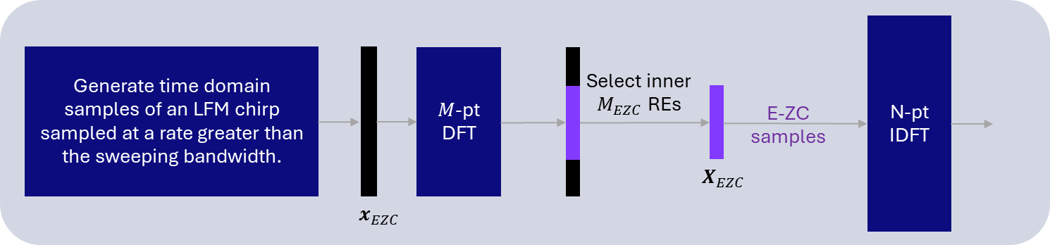
Figure 4-5 Illustration of a time-domain approach to generating E-ZC waveforms.
To get a ballpark number for obtaining the expansion factor $α$, we choose $M_{EZC}=αM_{ZC}$ corresponding to 20 dB bandwidth ($B_{20dB})$ as shown in Figure 4-5. From Figure 4-5, we see that although the expansion factor reduces with increase in #RBs, the total number of excess RBs still increases to achieve sufficiently low aliasing corresponding to $B_{20dB}$.
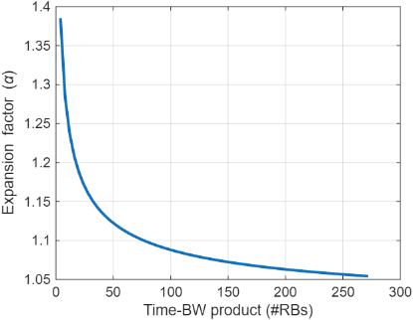  (a) | 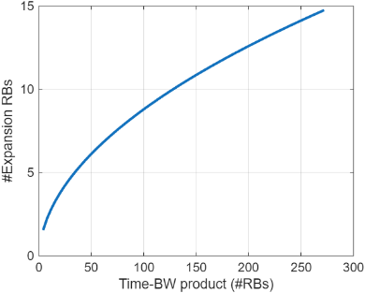  (b)
Figure 4-6 With an increase in time-bandwidth product ($T_{LFM} B_{LFM}$) of LFM chirp that sweeps over $\frac{M_{ZC}}{12}$#RBs, the expansion factor for EZC reduces, while number of excess RBs increases.
It is important to highlight that the expansion factor $α$ acts as a tunable parameter that can generate sequences that are either the same as 5G NR ZC sequences ($α =1$) or generate sequences that correspond to LFM chirps to varying degrees ($α$ > 1). This tunability offers the network the opportunity to potentially fine-tune these sequences for different use cases beyond CSI acquisition, such as sensing.
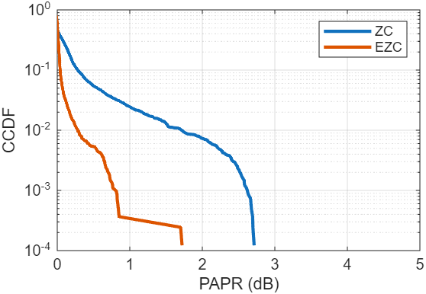 | 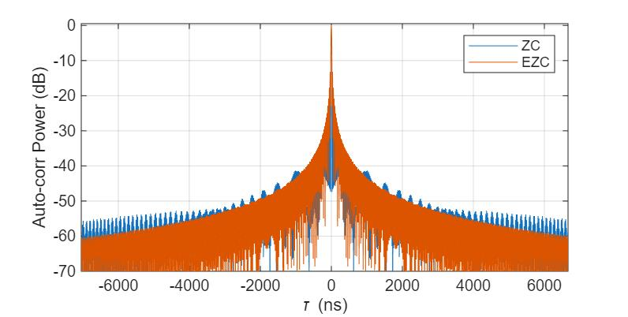
Figure 4-7 PAPR and autocorrelation for E-ZC as compared to ZC.

Figure 4-7 shows PAPR and autocorrelation characteristics of an E-ZC waveform and a ZC waveform. For this illustration, $M_{EZC}=1632$ with an expansion factor of $α= 1.07$ (based on the 20dB BW) is chosen. Considerable improvement in PAPR is observed while the autocorrelation is similar to that of a ZC waveform but with reduced far sidelobes.
Additional Considerations
(a) It is possible to derive analogs to ZC sequences with higher roots using a similar analysis as above. For higher roots, the starting point is a train of LFM chirps (instantaneous frequency exhibits a saw-tooth-like pattern) and the oversampling ratios tend to get larger.
(b) If desired, further improvements in these properties can also be achieved by introducing pulse shaping as an additional step. Pulse shaping (in time/freq domains) can significantly alter the overall auto-correlation characteristics of the sidelobes at the expense of a slightly enlarged main lobe. These could potentially be useful when pursuing a trade-off between target detection and tracking. An illustration of an improved autocorrelation is presented in the figure below when considering pulse shaping using a root-raised cosine in time domain.
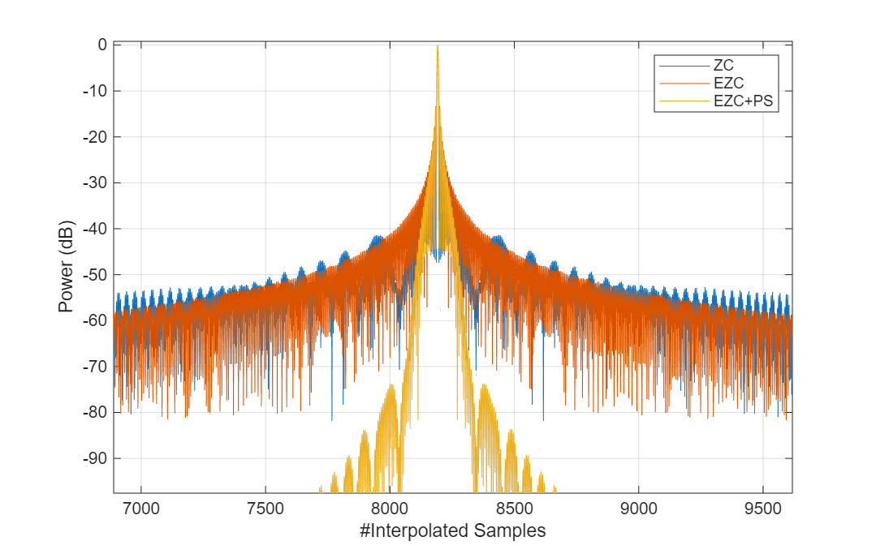
Figure 4-8 Autocorrelation for E-ZC and EZC+PS as compared to ZC
Based on these observations, we propose the following:
Proposal 4.2: Study enhanced Zadoff-Chu sequences to realize FMCW-like waveforms using an OFDM-based framework with specific focus on low PAPR and good autocorrelation properties.

Frame Structure Enhancements
The following agreement was made in RAN1-124bis meeting regarding the frame structure:

Agreement:
6GR communication frame structure is the starting point for 6G ISAC frame structure study, in at least the following aspects.
- Frame/sub-frame/slot/symbol structure
- CP length
- SCS
Enhancements on frame structure/above aspects are not precluded.

Also, the moderator made the following proposal:

[FL3][H] Proposal 5.2.2-4
Study the necessity/benefits and the applicable scenarios of enhancement at least for the following aspects, from perspective of the frame structure for 6G ISAC.
- CP length or effective CP length for ISAC (e.g. based on symbol repetition)
- SCS or effective SCS for ISAC (e.g. based on comb pattern)
- Guard period before/after/within sensing-RS symbol
- TDD resource configuration
Other enhancements are not precluded.

For each one of the potential enhancements described above we provide our views below.

Delays Beyond Normal CP Duration
Large delays are expected to be observed mainly (or only) in TRP monostatic and TRP-TRP bistatic scenarios, or UE monostatic scenarios where the UE Rx processing is not a bottleneck. For example, in a TRP–UE sensing scenario, the sensing signal shares the same timing reference as the downlink/uplink communication path. The UE is, by definition, within the TRP’s coverage and timing advance window, so the excess delay of sensing reflections relative to the communication path is limited. In a UE monostatic sensing scenario, for handheld device, the sensing round-trip is centered at the UE, and the sensed environment is typically local; the maximum sensing distance is therefore constrained, and the resulting delay remains within what existing OFDM receivers already handle. For a CPE monostatic sensing, or a scenario with large SCS (e.g. automotive monostatic sensing in mmW), even though delays beyond CPs may also occur, advanced multi-symbol FFT processing is not prohibitive. Finally, in a UE–UE bistatic sensing, both endpoints are UEs operating under network timing control. Their separation and sensing geometry are limited by practical proximity and synchronization constraints, preventing very large excess delays.

Focusing therefore mainly on the TRP monostatic scenarios, the two-way propagation delay of sensing links might indeed exceed the nominal cyclic prefix (CP) length used for communication. This is particularly evident in UAV TRP monostatic sensing, where background reflections may originate from distances well beyond the serving cell. For example, in the 3GPP monostatic background channel for UAV sensing, a significant fraction of background reflections arrive outside the CP window: With 30 kHz SCS, the normal CP corresponds to approximately 352 m one-way distance, and 3GPP channel statistics show that ~43% of background reflections have delays exceeding the CP. These delayed components can introduce ISI/ICI, which may appear as Doppler-domain artifacts in range-Doppler maps if processed with a naïve single-symbol receiver.
Observation 5.1: Larger delays beyond NCP are only expected for TRP monostatic and TRP-TRP bistatic scenarios.

Extended CP for Sensing
The prior observation points out a problem that can occur in practice; however the solution is not the support of extended CP. The argument against extended CP boils down to the following points:
- The problem is solvable at the receiver (multi-symbol processing, joint FFT) without any change to the transmitted waveform or frame structure — and this is unique to sensing because the transmitted signal is known. The observed ISI/ICI does not require strict per-symbol circular convolution to be mitigated: Back-to-back symbol processing (multi-symbol observation windows) naturally captures delayed energy spilling across symbol boundaries. Such receivers achieve higher SINR than the single-FFT baseline receiver, even in the presence of long-delay components. In practice, these techniques convert delay-induced ISI into exploitable diversity, rather than treating it as a hard impairment.

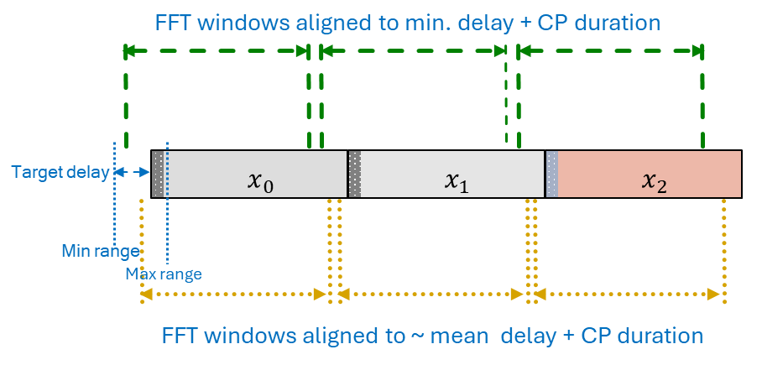
Figure 5-1 Multi-FFT approach to address sensing scenarios where delays can exceed CP duration.

- The problem is narrower than it appears — it only affects TRP monostatic and TRP-TRP bistatic scenarios, which can be addressed through advanced Rx processing.
- The cure is worse than the disease — ECP introduces spectral efficiency loss, frame structure disruption, slot boundary misalignment, and legacy coexistence problems that are disproportionate to the sensing performance gain, especially when receiver-side alternatives exist.
  - Legacy coexistence issues: Legacy receivers rely on strict slot boundary alignment. Variable CP lengths risk timing misalignment for devices unaware of sensing configurations.
  - Testing and certification complexity: New CP modes require new conformance tests, reference signals, and validation procedures across vendors.
- Some mitigation of larger delays is already possible via the use of reference signals with a 2-comb pattern that introduces an implicit repetition in the waveform that can be thought of as a long CP.
- Finally, considering that ECP is not going to be supported for communication scenarios, introducing this exclusively for sensing imposes an undue burden on implementation that doesn’t seem sufficiently justified.

Proposal 5.1: For 6GR ISAC, retain the existing CP design, and address large sensing delays through receiver-side processing.

Guard Period before/after/within Sensing-RS Symbol
For the scenarios of large delay spreads as discussed in the section above, specifying a guard symbol before or after a sensing RS could appear to be useful as it provides temporal isolation between transmission and reception and reduces sensitivity to long delays. However, it appears to be a rather resource-consuming solution. If indeed there are scenarios with large delay spreads that need to be addressed, transmitting sensing RS over multiple consecutive symbols and relying on advanced multi-symbol processing can significantly improve sensing performance and result to optimized solutions. As such, even though guard symbols offer a low-complexity solution, a multi-symbol processing is better positioned as an enhancement stage once waveform feasibility and integration aspects are established.

Observation 5.2: For scenarios characterized by large delay spreads, introducing a guard symbol before or after a sensing RS can provide temporal isolation between transmission and reception and reduce sensitivity to long delays. However, this approach incurs non-negligible resource overhead and may be inefficient.

For TRP monostatic sensing, any data or reference signals transmitted before or after a sensing RS can be naturally exploited within a multi-symbol processing framework to address scenarios with large delay spreads. In such scenarios, sensing echoes may arrive outside the nominal cyclic prefix window and span multiple OFDM symbols, particularly for background reflections or long-range targets. By coherently processing multiple consecutive symbols—regardless of whether they carry dedicated sensing RS or regular data—the receiver can effectively capture delayed energy, mitigate ISI/ICI effects, and improve range–Doppler estimation performance without requiring additional guard symbols. This approach enables more resource-efficient and optimized sensing operation, while leveraging existing CP-OFDM structures and advanced receiver processing capabilities.

Observation 5.3: For TRP monostatic sensing, any data (or RS) that are being transmitted before/after a sensing RS can be used within a multi-symbol processing framework to address scenarios with large delay spreads in an optimized sensing manner.

Proposal 5.2: For addressing scenarios with large delay spreads (e.g. TRP-TRP bistatic), prioritize solutions based on transmitting sensing RS over multiple consecutive symbols combined with advanced multi-symbol Rx processing.

Different SCS for Sensing from Communication
With the goal of repurposing the communication framework and promoting maximal reuse of hardware designed for communications, it is desirable that 6G ISAC reuse the overall communication frame structure. A single unified set of numerologies across both sensing and communications is likely to streamline hardware designs and paves the way for commercializing sensing as a use case on top of communication infrastructure with an incremental overhead.
The following potential problems have been identified, in which changing the SCS appears to be a potential solution:
Potential Problem 1: CP Coverage for Long-Range Sensing: The most widely cited problem is that the standard NR CP is too short for sensing. In communication, the CP only needs to cover the multipath delay spread (typically a few microseconds). In sensing, the signal must travel to the target and back — a round-trip delay that is twice the one-way propagation delay. This is then used to justify using a smaller SCS for sensing.
Answer to Potential Problem 1: The “CP is too short for long-range sensing” argument is only strictly true if the receiver is limited to conventional CP-based, single-symbol FFT processing. Once that assumption is relaxed, the conclusion no longer holds. This observation is mathematically correct under the communication-centric assumption that the receiver performs per-symbol FFT processing strictly aligned to the CP window, which requires the CP to absorb all excess delay in order to preserve circular convolution. However, this assumption is not fundamental for sensing. In particular, for TRP monostatic sensing scenarios, large delays beyond the CP are expected, but they do not require extended CP if more general receiver processing is allowed. In sensing, the objective is not symbol-by-symbol data demodulation but delay–Doppler estimation. As such:
- Delayed echoes that spill beyond the CP do not disappear; they simply spread across multiple OFDM symbols.
- By processing back-to-back symbols jointly (e.g., multi-symbol FFT windows, overlapping FFTs, or joint time-frequency processing), the receiver can capture the full delayed energy, even when the round-trip delay exceeds the CP.
- In this framework, ISI/ICI induced by long delays is not a hard impairment but a structured effect that can be mitigated—or even exploited—by advanced RX processing.
Multi-symbol processing converts delay-induced ISI into exploitable diversity and achieves significantly higher SINR than naïve single-FFT receivers, without any change to CP length, numerology, or frame structure.
Observation 5.4: The claim that the cyclic prefix is too short for long-range sensing holds only under conventional CP-aligned, single-symbol FFT reception, whereas in TRP monostatic (or bistatic) sensing, the use of multi-symbol receiver processing allows delayed echoes beyond the CP to be captured and exploited without extending the CP or modifying the numerology or frame structure.
Potential Problem 2: Resource Efficiency — Sensing Symbol Duration vs. Target Range: For short-to-medium range sensing, a 15 kHz symbol is "wasted" — the target echo returns long before the symbol ends. Using a larger SCS (shorter symbol) allows more sensing symbols within the same time budget, improving Doppler resolution and/or reducing latency.
Answer to Potential Problem 2: Since CP-OFDM is used as the baseline waveform, sensing reference signals (RS) can be efficiently multiplexed in frequency-domain with data or other functionalities (e.g., via different subcarriers or comb-based allocations). As a result, the full OFDM symbol duration is not exclusively reserved for sensing and therefore is not inherently wasted. This flexibility allows sensing and communication to coexist within the same symbol while preserving tight integration and minimizing resource overhead. If additional flexibility or efficiency is needed, a configurable pulse-based sensing option embedded within the CP-OFDM framework can be considered. By concentrating sensing energy into short, pulse-like segments within one or more OFDM symbols, the effective sensing duration can be matched to the target range while retaining the same SCS and frame structure. This approach addresses short-range efficiency and latency concerns, and can also help in scenarios with full-duplex limitations or large delay spreads, without introducing a separate numerology or disrupting coexistence with communication.
Observation 5.5: The claim that the SCS used for communication may be inefficient to short/medium range sensing due to the long duration is not valid since sensing RS can be FDMed with other RS and data if/as needed in these short/medium range deployments (e.g. indoor factor, indoor hotspot). If that is not considered sufficient, a pulse-based solution can be considered which will serve additional purposes (e.g. TRP monostatic sensing).
Potential Problem 3: Pulse Waveform Generation via Large SCS: Some companies propose to use a larger SCS as a mechanism to generate pulse-like waveforms within the OFDM framework. They are arguing that short symbol duration enables monostatic sensing (Tx/Rx separation in time), full transmit power during pulse, Low PAPR and small specification impact.
Answer to Potential Problem 3: To keep the blind zone sufficiently small, a sensing pulse must be very short. Since pulse-based sensing is primarily considered for TRP monostatic or bistatic operation—and given that conventional CP-OFDM-based sensing can already provide acceptable performance in full-duplex-limited scenarios for target ranges up to approximately 200–300 m—a pulse-based solution is only required beyond this range. This implies a pulse duration on the order of 2 µs. If such a pulse were to be generated by shortening the OFDM symbol duration via numerology change, it would require a subcarrier spacing on the order of 480 kHz to 960 kHz. These values are
- far beyond conventional NR/6GR SCS options intended for wide-area communication
- would introduce several fundamental drawbacks, including extremely short OFDM symbols, impractically small FFT sizes for realistic bandwidths,
- increased sensitivity to phase noise,
- significant impact on RF design, scheduling, and coexistence with communication.
Moreover, such large-SCS symbols would be difficult to multiplex with communication symbols due to incompatible symbol boundaries, would likely require dual FFT engines or dynamic numerology switching at the receiver, and could introduce additional challenges for multi-RAT spectrum sharing (MRSS). In contrast, the same effective pulse duration can be achieved more efficiently by embedding pulse-based sensing within a CP-OFDM framework—using time-domain shaping or pulsed-OFDM techniques—thereby avoiding the need for a different SCS altogether while preserving numerology alignment, hardware reuse, and tight integration with communication.
Observation 5.6: Generating a short sensing pulse (e.g., ~2 µs to limit blind range) by increasing SCS would require unrealistically large values (≈480–960 kHz), leading to severe numerology, RF, and coexistence challenges, whereas the same effective pulse duration can be achieved more efficiently by embedding pulse-based sensing within CP-OFDM without introducing a new SCS.
Proposal 5.3: For 6GR ISAC, do not introduce separate/dedicated SCS for sensing beyond those supported for communication.

Regarding the Waveform for TRP Sensing Modes
TRP monostatic sensing has been identified as one of the key sensing deployment modes under consideration for 6G. While TRP monostatic sensing can, in principle, be realized in a transparent manner using vendor-specific waveforms and processing, such an approach does not scale well in dense networks where sensing and communication operate concurrently over shared spectrum resources. In particular, without a specified sensing waveform, UEs are unable to perform meaningful measurements related to sensing activity (e.g., interference, occupancy, or sensing-induced impairment), and the network lacks a common basis for coordinating sensing behavior across TRPs and vendors. Furthermore, the absence of waveform specification limits the ability to study coexistence between sensing and communication, as well as sensing-to-sensing interference among neighboring TRPs. Therefore, specifying a waveform for TRP monostatic sensing enables a non-transparent operating framework where sensing transmissions are observable, measurable, and manageable within the system, while still allowing implementation flexibility at the receiver.
Observation 6.1: For TRP monostatic and TRP-bistatic sensing, leaving the sensing waveform entirely unspecified leads to a purely transparent and vendor-specific operation, which limits interoperability, prevents UE-assisted measurements and feedback, and hinders the study and control of interference and coexistence in dense deployments. As sensing activity scales spatially and temporally across a network, these limitations become increasingly critical.
Proposal 6.1: Strive to specify a waveform for TRP monostatic and TRP-bistatic sensing to enable UE measurements, coexistence studies, facilitate interoperability and interference management, and provide a common foundation for evaluating large-scale sensing deployments alongside communication services.

Conclusion
We make the following observations and proposals on 6G waveform for sensing:
On new waveform families
Observation 2.1: Many of the benefits of radar-native waveforms (e.g. FMCW, pulsed waveforms) can be approximated within an OFDM framework by synthesizing pulse-like or FMCW-like sequences using OFDM symbols. This approach preserves the core OFDM-based framework while enabling sensing-optimized sequence design, thus avoiding the need to introduce new waveforms specifically for sensing.

Observation 2.2: When evaluating new waveform families, it is important to consider the right receiver processing algorithms to ensure a fair comparison. In particular, when evaluating OFDM-based waveforms, limiting to single-symbol processing can lead to pessimistic results.

Proposal 2.1: For the ISAC waveform study, focus on enhancing the CP-OFDM waveform defined for 6GR, leveraging insights from radar-native and sensing-optimized waveforms.

On Sensing KPIs:
Observation 3.1: Waveform-characteristic analysis is the most suitable primary evaluation method for the ISAC waveform study, providing a clean, comparable, and low-risk foundation for waveform assessment.

Observation 3.2: LLS may appear to be useful as a secondary or follow-up tool, but it is not well suited in the absence of an agreed ISAC LLS model and lack of time in the study item.

Observation 3.3: SLS-based evaluation avoids the specification of a new channel model. Further, agreements on a concise set of constraints to drop targets and sensing-Tx/sensing-Rx nodes, can help isolate system-level dependencies from the ISAC waveform study, allowing for a cleaner waveform-level evaluation.

Proposal 3.1: For evaluating different waveforms for sensing, consider at least the following two sets of KPIs:
- Waveform characteristics
  - PAPR
  - Ambiguity function characteristics (e.g. auto-corr, ISLR, PSLR)
  - Cross correlation
  - Time/freq. waveform confinement
  - Emissions compliance
  - Resilience to ISI and/or ICI
- System-level performance
  - Missed Detection probability
  - False Alarm probability (Type 1 & 2)
  - Horizontal/vertical positioning Accuracy
  - Velocity Accuracy
  - latency
  - Integration/harmonization between sensing & communication
  - Transmitter/Receiver complexity
  - Low sensing overhead

Proposal 3.2: For the ISAC waveform study in RAN1, use the theoretical waveform characteristics analysis as the primary evaluation method, and complement it with a SLS with agreed evaluation assumptions tailored for ISAC waveform evaluation study.

Proposal 3.3: For the ISAC waveform study in RAN1, for the waveform-tailored SLS evaluation assumptions, consider at least the following:
- Single sensing transmitter (STx) and single sensing receiver (SRx)
- Single cell / interference-free
- One or two sensing targets
- LOS STx-target and target-SRx conditions
- Near (high SNR) and far away (low SNR) regimes

On enhancements based on communication waveforms:
Proposal 4.1: Consider pulse-based waveforms for 6G ISAC waveform study. Study how pulse-based waveforms can be generated using 6G communication’s OFDM-based waveform generation framework.
Observation 4.1: Upsampled waveforms constructed using ZC sequences do not exhibit a constant amplitude.
Observation 4.2: A Zadoff-Chu sequence with time-domain root $q_{t} = 1$ and length $M_{ZC}$ can be derived from a LFM chirp that sweeps over $M_{ZC}Δ_{scs}$ bandwidth by taking $M_{ZC}$ equidistant samples over an OFDM symbol duration.
Observation 4.3: Spectrum of an LFM chirp extends beyond sweeping bandwidth. Therefore, ZC sequence derived from LFM chirp sampled at sweeping bandwidth suffers from aliasing.
Proposal 4.2: Study enhanced Zadoff-Chu sequences to realize FMCW-like waveforms using an OFDM-based framework with specific focus on low PAPR and good autocorrelation properties.

On frame structure enhancements
Observation 5.1: Larger delays beyond NCP are only expected for TRP monostatic and TRP-TRP bistatic scenarios.
Observation 5.2: For scenarios characterized by large delay spreads, introducing a guard symbol before or after a sensing RS can provide temporal isolation between transmission and reception and reduce sensitivity to long delays. However, this approach incurs non-negligible resource overhead and may be inefficient.

Observation 5.3: For TRP monostatic sensing, any data (or RS) that are being transmitted before/after a sensing RS can be used within a multi-symbol processing framework to address scenarios with large delay spreads in an optimized sensing manner.

Observation 5.4: The claim that the cyclic prefix is too short for long-range sensing holds only under conventional CP-aligned, single-symbol FFT reception, whereas in TRP monostatic (or bistatic) sensing, the use of multi-symbol receiver processing allows delayed echoes beyond the CP to be captured and exploited without extending the CP or modifying the numerology or frame structure.
Observation 5.5: The claim that the SCS used for communication may be inefficient to short/medium range sensing due to the long duration is not valid since sensing RS can be FDMed with other RS and data if/as needed in these short/medium range deployments (e.g. indoor factor, indoor hotspot). If that is not considered sufficient, a pulse-based solution can be considered which will serve additional purposes (e.g. TRP monostatic sensing).
Observation 5.6: Generating a short sensing pulse (e.g., ~2 µs to limit blind range) by increasing SCS would require unrealistically large values (≈480–960 kHz), leading to severe numerology, RF, and coexistence challenges, whereas the same effective pulse duration can be achieved more efficiently by embedding pulse-based sensing within CP-OFDM without introducing a new SCS.
Proposal 5.1: For 6GR ISAC, retain the existing CP design, and address large sensing delays through receiver-side processing.

Proposal 5.2: For addressing scenarios with large delay spreads (e.g. TRP-TRP bistatic), prioritize solutions based on transmitting sensing RS over multiple consecutive symbols combined with advanced multi-symbol Rx processing.

Proposal 5.3: For 6GR ISAC, do not introduce separate/dedicated SCS for sensing beyond those supported for communication.

On waveforms for TRP sensing modes
Observation 6.1: For TRP monostatic and TRP-bistatic sensing, leaving the sensing waveform entirely unspecified leads to a purely transparent and vendor-specific operation, which limits interoperability, prevents UE-assisted measurements and feedback, and hinders the study and control of interference and coexistence in dense deployments. As sensing activity scales spatially and temporally across a network, these limitations become increasingly critical.
Proposal 6.1: Strive to specify a waveform for TRP monostatic and TRP-bistatic sensing to enable UE measurements, coexistence studies, facilitate interoperability and interference management, and provide a common foundation for evaluating large-scale sensing deployments alongside communication services.

References
[1] P. Kumari et al., "Integrated Communication and Sensing for Meeting Automotive Requirements in 5G/6G Connected Vehicles," 2024 IEEE 100th Vehicular Technology Conference (VTC2024-Fall), Washington, DC, USA, 2024, pp. 1-7.

